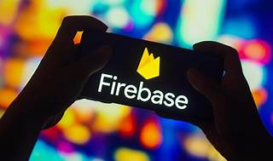

Explore

**Firebase** is **Google’s mobile application development platform** that helps you build, improve, and grow your app. It offers a suite of products for analytics, authentication, databases, push messaging, and more. [You can use Firebase with various languages and platforms, such as iOS, Android, web, Unity, and C++1](https://firebase.google.com/).

Here are **five free reference links** where you can learn more about Firebase:

1. [**Firebase Official Documentation**](https://firebase.google.com/): Explore detailed documentation, cross-platform app development SDKs, and learn how to integrate Firebase products into your apps.
2. [**Medium: What is Firebase? The complete story, abridged.**](https://medium.com/firebase-developers/what-is-firebase-the-complete-story-abridged-bcc730c5f2c0): A concise overview of Firebase’s features and functionalities.
3. [**Udacity: Firebase for Android**](https://www.udacity.com/course/firebase-in-a-weekend-by-google-android--ud0352): Take this free course to learn how to build an app using Firebase.
4. [**Udemy: Firebase Fundamentals**](https://www.udemy.com/course/firebase-fundamentals/): Learn how to use Firebase for site hosting, Firestore, Cloud Functions, and authentication.
5. [**Class Central: Firebase – Full Course for Beginners**](https://www.classcentral.com/course/freecodecamp-firebase-full-course-for-beginners-104847): Covering authentication, Firestore database, storage, realtime updates, and more.

Happy learning! 🚀🔥